# Problem 3 – Autumn

Create a web page (**HTML5 + CSS3 + images**) that looks and behaves like the screenshots below:

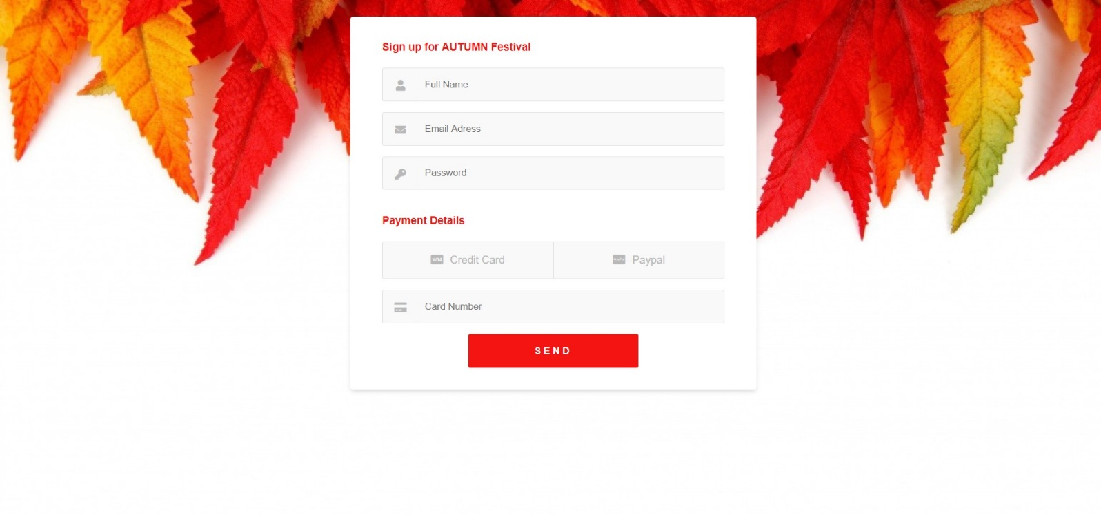

You are given the above screenshots + all required images.

### Output

The output should be valid **HTML5** + **CSS3** + **images** that implement the above web page.

### Constraints

* Use Google font - **“Open Sans”** - <https://fonts.google.com/specimen/Open+Sans>
* Use **font awesome** for icons
* The site should open correctly in the latest version of Chrome
* Pixel-perfect implementation is **NOT** required
* Implement hover effects